# Durable Furnitures

Artistica

## Monterey Cherry Storage Bed

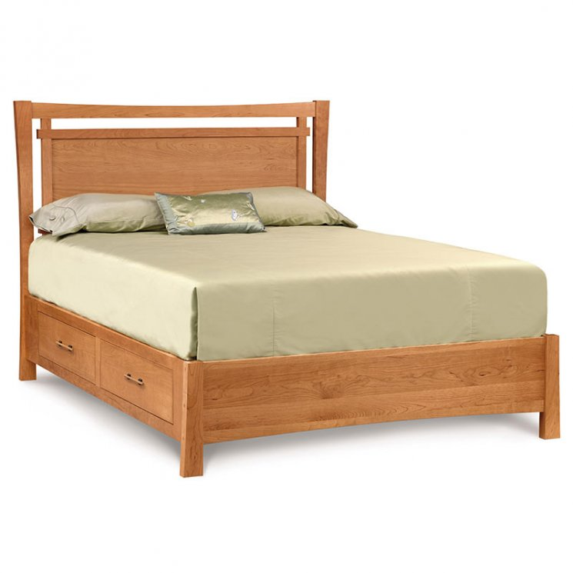

Luxury, high end, solid cherry wood, Monterey Bed with underbed storage fuses American Art's & Crafts style with modern Japanese and Asian design.